Written By: Aidan Jacobsen
Date: 4/11/2024
Generating Hex Files To Select STARS Designs
Purpose: The purpose of this document is to explain how to generate the hex files that are used to select a design on the 2023 STARS chip. To learn about how to use these files once generated, please see the other testing documentation.
Estimated Time to Complete Tutorial: 2-3 hours effort, 10 hours installation
Overview of Process: The STARS chip consists of 12 hardened macros generated by each of the teams of 4. These 12 designs are arranged in a grid-like pattern (see figure 1) with a small amount of logic to multiplex the designs. This macro is then placed within a ‘caravel harness’ that contains a RISC-V processor and all the GPIO. To select a design, the processor must be used. The processor has access to many (~128 logic analyzer signals) that can interface with the user project area. With 12 designs, we use the least significant 4 bits of this bus to directly connect the gpio to the desired design. To flash this processor, a hex file must be generated using the RISC-V toolchain. This tutorial walks through how to use WSL to generate the .hex files that are flashed onto the board using python.
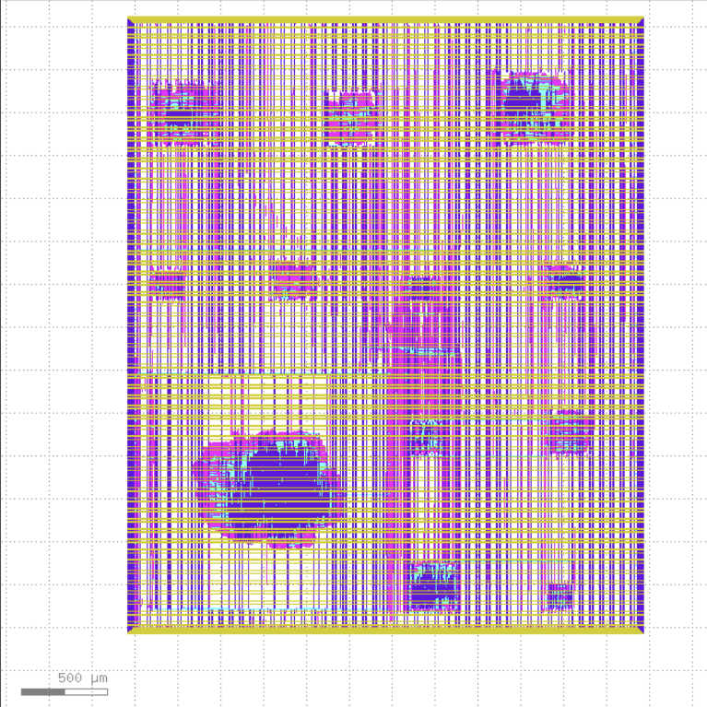
Figure 1: Image showing the arrangement of the 12 team designs without the caravel harness.

Step 1: Enable Windows Subsystem for Linux (WSL)
- Open an admin instance of powershell and run
Wsl --install
- Restart your computer
- In powershell, install Ubuntu for wsl and generate a default user
Wsl --install Ubuntu
- To launch wsl in the future, use (powershell):
Wsl -d Ubuntu
- Add an ssh key for Ubuntu within WSL (then add this to GitHub like normal)
ssh-keygen -t ed25519 -C your_email@example.com
- Test git access by running (WSL):
ssh -T git@github.com
For more information, visit: https://learn.microsoft.com/en-us/windows/wsl/install
Step 2: Install the RISC-V Toolchain
- Clone the RISC-V toolchain Repo (WSL)
git clone git@github.com:riscv-collab/riscv-gnu-toolchain.git
- Enable case sensititivity on the toolchain repo using an admin instance of powershell. Run the following within the riscv-gnu-toolchain directory generated in the previous step. See (https://stackoverflow.com/questions/51591091/apply-setcasesensitiveinfo-recursively-to-all-folders-and-subfolders) for more information.
(Get-ChildItem -Recurse -Directory).FullName | ForEach-Object {fsutil.exe file setCaseSensitiveInfo $_ enable}
- Confirm that the base directory is also case sensitive.
fsutil.exe file setCaseSensitiveInfo <filepath to folder containing riscv-gnu-toolchain> enable
- Check case sensitivity using (admin powershell):
fsutil.exe file queryCaseSensitiveInfo <filepath to folder containing riscv-gnu-toolchain>
- Install the toolchain within wsl (this took like 10 hours to complete):
Cd riscv-gnu-toolchain
./configure --prefix=/opt/riscv
Make linux

Step 3: Clone the Efabless Repo:
- Clone the Efabless Repo
Git clone git@github.com:efabless/caravel_board.git

Step 4: Create required files:
- This should generate a caravel_board root directory. Navigate to caravel_board/firmware/chipignite
- Create a new directory to contain the Makefile and load.c
  - The modifications to the Makefile included the toolchain prefix / path and changing -march=rv32i to -march=rv32i_zicsr
TOOLCHAIN_PATH=/opt/riscv/bin/

# Set the prefix for `riscvXX-unknown-elf-*`
# On installations using `multilib`, this will be `riscv64` even for compiling to 32-bit targets
TOOLCHAIN_PREFIX=riscv64-unknown-linux-gnu
#ARCH=rv32i_zicsr
ARCH=rv32i

# ---- Test patterns for project raven ----

.SUFFIXES:

PATTERN = load

hex: ${PATTERN:=.hex}

%.elf: %.c ../sections.lds ../crt0_vex.S
#$(TOOLCHAIN_PATH)riscv32-unknown-elf-gcc -O0 -march=rv32i -Wl,-Bstatic,-T,../sections.lds,--strip-debug -ffreestanding -nostdlib -o $@ ../start.s ../print_io.c $<
$(TOOLCHAIN_PATH)$(TOOLCHAIN_PREFIX)-gcc -I../ -I../generated/ -O0 -mabi=ilp32 -march=$(ARCH) -D__vexriscv__ -Wl,-Bstatic,-T,../sections.lds,--strip-debug -ffreestanding -nostdlib -o $@ ../crt0_vex.S ../isr.c ../stub.c $<
${TOOLCHAIN_PATH}$(TOOLCHAIN_PREFIX)-objdump -D load.elf > load.lst

%.hex: %.elf
$(TOOLCHAIN_PATH)$(TOOLCHAIN_PREFIX)-objcopy -O verilog $< $@
sed -ie 's/@1000/@0000/g' $@

%.bin: %.elf
$(TOOLCHAIN_PATH)$(TOOLCHAIN_PREFIX)-objcopy -O binary $< $@

client: client.c
gcc client.c -o client

flash: load.hex
python3 ../util/caravel_hkflash.py load.hex

flash2: load.hex
python3 ../util/caravel_flash.py load.hex

show_projectid:
python3 ../util/caravel_projectid.py

# ---- Clean ----

clean:
rm -f *.elf *.hex *.bin *.vvp *.vcd

.PHONY: clean hex all flash

#include <defs.h>
#include <stub.h>

// --------------------------------------------------------
// Firmware routines
// --------------------------------------------------------

void configure_io()
{

// ======= Useful GPIO mode values =============

// GPIO_MODE_MGMT_STD_INPUT_NOPULL
// GPIO_MODE_MGMT_STD_INPUT_PULLDOWN
// GPIO_MODE_MGMT_STD_INPUT_PULLUP
// GPIO_MODE_MGMT_STD_OUTPUT
// GPIO_MODE_MGMT_STD_BIDIRECTIONAL
// GPIO_MODE_MGMT_STD_ANALOG

// GPIO_MODE_USER_STD_INPUT_NOPULL
// GPIO_MODE_USER_STD_INPUT_PULLDOWN
// GPIO_MODE_USER_STD_INPUT_PULLUP
// GPIO_MODE_USER_STD_OUTPUT
// GPIO_MODE_USER_STD_BIDIRECTIONAL
// GPIO_MODE_USER_STD_ANALOG

// ======= set each IO to the desired configuration =============

// GPIO 0 is turned off to prevent toggling the debug pin; For debug, make this an output and
// drive it externally to ground.

reg_mprj_io_0 = GPIO_MODE_USER_STD_BIDIRECTIONAL;

// Changing configuration for IO[1-4] will interfere with programming flash. if you change them,
// You may need to hold reset while powering up the board and initiating flash to keep the process
// configuring these IO from their default values.
// As such, we do not use GPIO 1-4.
reg_mprj_io_1 = GPIO_MODE_MGMT_STD_OUTPUT;
reg_mprj_io_2 = GPIO_MODE_MGMT_STD_INPUT_NOPULL;
reg_mprj_io_3 = GPIO_MODE_MGMT_STD_INPUT_NOPULL;
reg_mprj_io_4 = GPIO_MODE_MGMT_STD_INPUT_NOPULL;

// In the following sections, GPIO 5-37 are configured to allow for the user projects to access them.
// The chip has a management core that could also use these GPIO if they were set to GPIO_MODE_MGMT_STD_OUTPUT.
// This is setting some registers in the chip to prepare for loading this data into the registers that are
// physcially closer to the GPIO pins on the chip.
reg_mprj_io_5 = GPIO_MODE_USER_STD_BIDIRECTIONAL; // UART Rx
reg_mprj_io_6 = GPIO_MODE_USER_STD_BIDIRECTIONAL; // UART Tx
reg_mprj_io_7 = GPIO_MODE_USER_STD_BIDIRECTIONAL;
reg_mprj_io_8 = GPIO_MODE_USER_STD_BIDIRECTIONAL;
reg_mprj_io_9 = GPIO_MODE_USER_STD_BIDIRECTIONAL;
reg_mprj_io_10 = GPIO_MODE_USER_STD_BIDIRECTIONAL;
reg_mprj_io_11 = GPIO_MODE_USER_STD_BIDIRECTIONAL;
reg_mprj_io_12 = GPIO_MODE_USER_STD_BIDIRECTIONAL;
reg_mprj_io_13 = GPIO_MODE_USER_STD_BIDIRECTIONAL;
reg_mprj_io_14 = GPIO_MODE_USER_STD_BIDIRECTIONAL;
reg_mprj_io_15 = GPIO_MODE_USER_STD_BIDIRECTIONAL;
reg_mprj_io_16 = GPIO_MODE_USER_STD_BIDIRECTIONAL;
reg_mprj_io_17 = GPIO_MODE_USER_STD_BIDIRECTIONAL;
reg_mprj_io_18 = GPIO_MODE_USER_STD_BIDIRECTIONAL;
reg_mprj_io_19 = GPIO_MODE_USER_STD_BIDIRECTIONAL;
reg_mprj_io_20 = GPIO_MODE_USER_STD_BIDIRECTIONAL;
reg_mprj_io_21 = GPIO_MODE_USER_STD_BIDIRECTIONAL;
reg_mprj_io_22 = GPIO_MODE_USER_STD_BIDIRECTIONAL;
reg_mprj_io_23 = GPIO_MODE_USER_STD_BIDIRECTIONAL;
reg_mprj_io_24 = GPIO_MODE_USER_STD_BIDIRECTIONAL;
reg_mprj_io_25 = GPIO_MODE_USER_STD_BIDIRECTIONAL;
reg_mprj_io_26 = GPIO_MODE_USER_STD_BIDIRECTIONAL;
reg_mprj_io_27 = GPIO_MODE_USER_STD_BIDIRECTIONAL;
reg_mprj_io_28 = GPIO_MODE_USER_STD_BIDIRECTIONAL;
reg_mprj_io_29 = GPIO_MODE_USER_STD_BIDIRECTIONAL;
reg_mprj_io_30 = GPIO_MODE_USER_STD_BIDIRECTIONAL;
reg_mprj_io_31 = GPIO_MODE_USER_STD_BIDIRECTIONAL;
reg_mprj_io_32 = GPIO_MODE_USER_STD_BIDIRECTIONAL;
reg_mprj_io_33 = GPIO_MODE_USER_STD_BIDIRECTIONAL;
reg_mprj_io_34 = GPIO_MODE_USER_STD_BIDIRECTIONAL;
reg_mprj_io_35 = GPIO_MODE_USER_STD_BIDIRECTIONAL;
reg_mprj_io_36 = GPIO_MODE_USER_STD_BIDIRECTIONAL;
reg_mprj_io_37 = GPIO_MODE_USER_STD_BIDIRECTIONAL;

// This section flips the bit in the transfer register that causes all of the GPIO configurations to be passed to the
// registers that directly control the GPIO pins. See the documentation for more details.
// https://github.com/efabless/caravel/blob/cd263ed24b9e41cb9a37aabbfad09e57f40ad1e9/docs/other/gpio.txt
reg_mprj_xfer = 1;
while (reg_mprj_xfer == 1);
}

void delay(const int d)
{

/* Configure timer for a single-shot countdown */
reg_timer0_config = 0;
reg_timer0_data = d;
reg_timer0_config = 1;

// Loop, waiting for value to reach zero
reg_timer0_update = 1; // latch current value
while (reg_timer0_value > 0) {
reg_timer0_update = 1;
}

}

void main()
{
int i, j, k;

reg_gpio_mode1 = 1;
reg_gpio_mode0 = 0;
reg_gpio_ien = 1;
reg_gpio_oe = 1;//enables the output (to write to led)

configure_io();

//https://github.com/efabless/caravel_user_project/blob/main/verilog/dv/io_ports/io_ports.c#L49
reg_spi_enable = 1;
reg_spimaster_cs = 0x10001;
reg_spimaster_control = 0xa002;//enable housekeeping SPI, enable SPI, prescalar = 2

reg_uart_enable = 1;

// Configure All LA probes as inputs to the cpu
reg_la0_oenb = 0xffffffff; // [31:0]
reg_la1_oenb = 0xffffffff; // [63:32]
reg_la2_oenb = 0xffffffff; // [95:64]
reg_la3_oenb = 0xffffffff; // [127:96]

reg_la0_iena = 0x00000000; // [31:0]
reg_la1_iena = 0x00000000; // [63:32]
reg_la2_iena = 0x00000000; // [95:64]
reg_la3_iena = 0x00000000; // [127:96]

// write data to LA output to select Guitar Villains project (LA[3:0]=4'd5)
reg_la0_data = 0x05;

print("Configured");

while (1) {

reg_gpio_out = 1; // OFF

delay(2000000);
// delay(8000000);

reg_gpio_out = 0; // ON

delay(2000000);
// delay(8000000);

}

}

Step 5: Enable USB support for WSL (Optional; if you don’t you won’t be able to flash the chip from within WSL)
- Install usbipd by downloading the .msi file from: https://learn.microsoft.com/en-us/windows/wsl/connect-usb
- Open an instance of WSL from within power shell.
- Within cmd, run the following:
Usbipd list
- Plug in the Caravel board
Usbipd list
- Identify the busid (like 2-4) for the Caravel board. There might be a better way to do this. Run the following adjusting the bus id as needed. The bind command should only need to be run once. The attach will need to be run every time the board is connected.
Usbipd bind --busid 2-4
Usbipd attach --wsl --busid 2-4

Step 6: Install python, pyftdi
- Within WSL, install python and pyftdi
sudo apt-get update
sudo apt install python3-pip
pip3 install pyftdi

Step 7: Generate hex file and flash device:
- Within WSL and with the caravel_usb attached through usbipd, navigate to the project directory and make the hex files (this also flashes the devices)
Cd caravel_board/firmware/chipignite/<project folder>
Make clean flash
- To change the group for which the hexfile is generated, the following line can be edited in load.c
reg_la0_data = 0x05;

